
HAMPSHIRE JUNIOR CHESS ASSOCIATION
ANNUAL JUNIOR OPEN CHESS CONGRESS
On Sunday 6th October 2019
At New Hall, Winchester College, Wharf Hill, Winchester
SCHEDULE:
ARRIVE: 09.00, Round 1: 09.30, Round 2: 10.30, Round 3: 11.30, Lunch: 12.30, Round 4: 13.00, Round 5: 14.00, Round 6: 15.00, PRIZEGIVING: 16.10
TIME CONTROL: Rapidplay, 20 minutes plus a ten second increment each.
PRIZES: determined by the entrants’ age on 31st August 2019.
Under 8, Under 10 and Under 12: Trophies for the 1st, 2nd, 3rd and 4th places and the best girl in each age group. As well as trophies there will be chess book prizes.
Under 14, Under 16 and Under 18: 1st place: £60, 2nd place: £40, 3rd place: £20, best girl: £50 and trophies for the winners in each age group. These are guaranteed prizes. With enough entries, prizes may be increased at the Congress Controller’s discretion.
SECTIONS: Age groups will be combined into playing sections and notified before round 1.
ENTRY FEES and RULES:
- Entry fee for Under 8, Under 10 and Under 12: £20
- Entry fee for Under 14, Under 16 and Under 18: £20
- Late entry fee for entries received after Wednesday 2nd October 2019: £5.00
- Congress results will be submitted to the English Chess Federation (ECF) for grading
- Entrants must either be a Silver or higher ECF member, or pay a Pay-to-Play fee
- Bronze ECF members must pay a fee of £7.50 to upgrade from Bronze to Silver
- Non-ECF members can pay a £2.50 Pay-to-Play fee or apply via the ECF web site for a free 1 year Silver membership provided they have not been an ECF member before.
- Getting sufficient points in the U8, U10 and U12 age groups will enable qualification to the London Junior Chess Championships : further Information below.
ON-LINE ENTRY
If preferred (and we would prefer this !) you may enter and pay on-line via our secure entry system. Please visit :
https://www.eventbrite.co.uk/hjcacongress
ENTRY FORM
HAMPSHIRE JUNIOR OPEN CONGRESS: SUNDAY 6th OCTOBER 2019
Please use BLOCK CAPITAL letters to fill in the form
Only one entrant and one on-line payment per form please
FAMILY NAME: _______________________________________________________________
GIVEN NAME: _______________________________________________________________
PAYMENT REFERENCE (19HJC-first 4 characters of family name-first 4 characters of given name such as 19HJC-SMIT-JOHN for John Smith): 19HJC- _ _ _ _ - _ _ _ _
ACCOUNT NAME FOR MONEY WINNER CHEQUES: __________________________________
ADDRESS: ___________________________________________________________________
eMail: _____________________________________________________________________
Telephone / Mobile: __________________________________________________________
DATE of BIRTH: __________________ AGE: _____ MALE or FEMALE (tick): M ___ F ___
SCHOOL and/or CLUB: _________________________________________________________
[For ECF information, put the entrant’s name into the ECF Grading Database, address below]
ECF MEMBERSHIP NUMBER: __________ ECF MEMBERSHIP CLASS (B/S/G/P): __________
ECF GRADING CODE: ________________ ECF RAPIDPLAY GRADE: __________
ENTRY FEE (£20): £ _________ LATE FEE (£5 if after 2nd October 2019): £ _____
BRONZE TO SILVER UPGRADE (£7.50): £ _______ PAY-TO-PLAY FEE (£2.00) £ __________
DONATION: £________
TOTAL £________
I accept the conditions of entry (Parent or Guardian for minors)
Signature ____________________________________________ Date _________________
Entry forms and cheques payable to Hampshire Junior Chess Association should be posted to David Graham, 12 Mallard Close, Kempshott, Basingstoke, Hampshire. RG22 5JP or emailed to davidgrahambcs@yahoo.co.uk . Payment may also be made by bank transfer to Account name: Hampshire Junior Chess Association, Sort Code: 30-93-17, Account No.: 66611460, Payment reference from form above: 19HJC- _ _ _ _ - _ _ _ _ , Bank: Lloyds Bank
INFORMATION
The College is enclosed and a safe environment for children but announcements will be made at the commencement of the competition.
Coaching :
We are delighted to announce that we will have at least one accredited coach in attendance. He or she will observe games and provide group training sessions between rounds. Details will be announced once they are confirmed.
BRITISH CHESS NEWS:
John Upham will be in attendance and cover the Congress for British Chess News, see below.
HAMPSHIRE JUNIOR CHESS ASSOCIATION:
Information on forthcoming events will be provided by the above association, Internet address below.
QUALIFICATION FOR THE LONDON JUNIOR CHESS CHAMPIONSHIPS:
The criteria for qualification for the LJCC finals are:
- The qualification score for the Under 8 Final is 4 or more out or 6
- The qualification score for the Under 10 Minor Final and Under 12 Minor Final is 3 1⁄2 or 4 out of 6.
- The qualification score for the Under 10 Major Final and Under 12 Major Final is 4 1⁄2 or more out of 6.

PHOTOGRAPHY:
No photography will be permitted within the playing area during play. The organisers will use an official photographer to take stills and videos for publicity purposes. Please inform the organisers in advance if you wish your child to be excluded from the photographs or videos.
REFRESHMENTS:
The College Shop in New Hall will be open for most of the day and offers tea, coffee and a selection of savouries.
USEFUL INTERNET ADDRESSES:
- Winchester College : www.winchestercollege.org
- Hampshire Junior Chess Association (HJCA) : www.hjca.org.uk
- Hampshire Chess Association (HCA) : www.hampshirechess.co.uk
- English Chess Federation (ECF) : www.englishchess.org.uk
- ECF Grading Database : www.ecfgrading.org.uk
- London Junior Chess Championships (LJCC) : www.ljcc.co.uk
- British Chess News : www.facebook.com/groups/britishchess
- British Chess News : www.britishchessnews.com

LOCATION
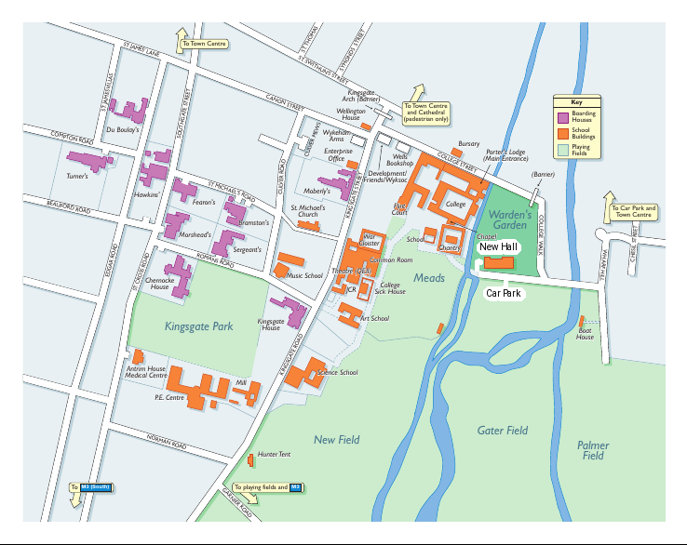
The Congress will be held in New Hall, Winchester College, Wharf Hill, Winchester shown in the middle of the right hand side of this map. Access is from the East along Chesil Street and Wharf Hill. Parking will be available in St. Elizabeth’s Mead opposite New Hall. Note that the postcode for the College will take you to the Porter’s Lodge entrance from which there is no vehicular access to Wharf Hill.

